भारत मौसम विज्ञान विभाग |  | India Meteorological Department
Saturday 23rd May 2026 (02nd Jyaistha 1948 Saka)
Summary of observations recorded at 0830 hours IST: Southwest Monsoon has further advanced into some parts of southwest Arabian Sea, some more parts of southeast Arabian Sea, Comorin area, southwest, southeast and eastcentral Bay of Bengal and most parts of Andaman Sea today, the 23rd May 2026. The Northern Limit of Monsoon passes through 7°N/60°E, 7°N/70°E, 7°N/75°E, 8°N/80°E, 10°N/85°E, 13.5°N/90°E, and 17°N/95°E as on 23rd May 2026. Conditions are favourable for further advance of southwest monsoon into some more parts of southwest & southeast Arabian Sea, Comorin Area, southwest, southeast & eastcentral Bay of Bengal and remaining parts of Andaman Sea during next 3-4 days. The Western disturbance as a cyclonic circulation over north Pakistan & neighbourhood lay over Jammu & neighbourhood at 3.1 km above m. s. l. at 0530 hrs IST of today. It persisted over the same region. However, the trough aloft in middle and upper tropospheric westerlies with its axis at 5.8 km above m. s. l. ran roughly along Long. 75°E to the north of Lat. 25°N at 1730 hrs IST of yesterday, the 22nd May 2026. It moved away east-northeastwards at 0530 hrs IST of today. The upper air cyclonic circulation over central Assam & neighbourhood persisted and extended upto 1.5 km above m. s. l. The upper air cyclonic circulation over Southeast Bay of Bengal & neighbourhood lay over Southeast adjoining central Bay of Bengal between 3.1 & 5.8 km above m. s. l. tilting southwestwards with height. The north - south trough from the upper air cyclonic circulation over northwest Uttar Pradesh to the upper air cyclonic circulation over interior Odisha ran from the upper air cyclonic circulation over southwest Bihar to north coastal Andhra Pradesh across Jharkhand, north Chhattisgarh, and interior Odisha at 0.9 km above m. s. l. at 0530 hrs IST of today. It persisted over the same region. An upper air cyclonic circulation lay over south Bihar & neighbourhood at 0.9 km above m. s. l. at 0530 hrs IST of today. It persisted over the same region. A trough ran from Punjab to Southwest Rajasthan at 1.5 km above m. s. l. A trough in westerlies with its axis at 5.8 km above m. s. l. ran roughly along Long. 90°E to the north of Lat. 23°N. An upper air cyclonic circulation lay over Southwest Arabian sea between 3.1 & 5.8 km above m. s. l. The upper air cyclonic circulation over eastcentral Arabian Sea & neighbourhood became less marked. The trough from the upper air cyclonic circulation over Southeast Arabian Sea to Comorin area across Kerala and south Tamil Nadu became less marked. The upper air cyclonic circulation over southeast Arabian Sea & neighbourhood became less marked. An upper air cyclonic circulation lay over Rayalaseema and adjoining South coastal Andhra Pradesh at 3.1 km above m. s. l. at 0530 hrs IST of today. It became less marked. The trough from the upper air cyclonic circulation over Southeast Bay of Bengal to north Kerala across Southwest Bay of Bengal and Tamil Nadu became less marked at 0530 hrs IST of today. The upper air cyclonic circulation northwest Uttar Pradesh & neighbourhood became less marked at 0530 hrs IST of today. The upper air cyclonic circulation over interior Odisha & neighbourhood became less marked at 0530 hrs IST of today. A fresh western disturbance likely to affect Northwest India from 28th May, 2026.
Maximum Temperature Departures (as on 22-05-2026): markedly above normal (> 5.1°C) at many places over Uttarakhand; at few places over Arunachal Pradesh, West Madhya Pradesh and East Madhya Pradesh; at isolated places over Assam & Meghalaya, East Uttar Pradesh, West Uttar Pradesh, Jammu-Kashmir and Ladakh-Gilgit-Baltistan Muzaffarabad, Vidarbha, Chhattisgarh, Coastal Andhra Pradesh & Yanam and Tamil Nadu, Puducherry & Karaikal. appreciably above normal (3.1°C to 5.0°C) at few places over Odisha and Himachal Pradesh; at isolated places over Nagaland, Manipur, Mizoram & Tripura, Jharkhand, Haryana-Chandigarh-Delhi, Gujarat Region, Saurashtra & Kutch, Konkan & Goa and Telangana. above normal (1.6°C to 3.0°C) at most places over Punjab; at isolated places over Sub Himalayan West Bengal & Sikkim, Gangetic West Bengal, Bihar, Madhya Maharashtra and Marathwada. near normal (-1.5°C to 1.5°C) at many places over Lakshadweep; at most places over West Rajasthan, East Rajasthan and Coastal Karnataka; at few places over Andaman & Nicobar Islands, Rayalaseema, South Interior Karnataka and Kerala & Mahe; at isolated places over North Interior Karnataka. The highest maximum temperature of 47.2°C was reported at Brahmpuri (Vidarbha).

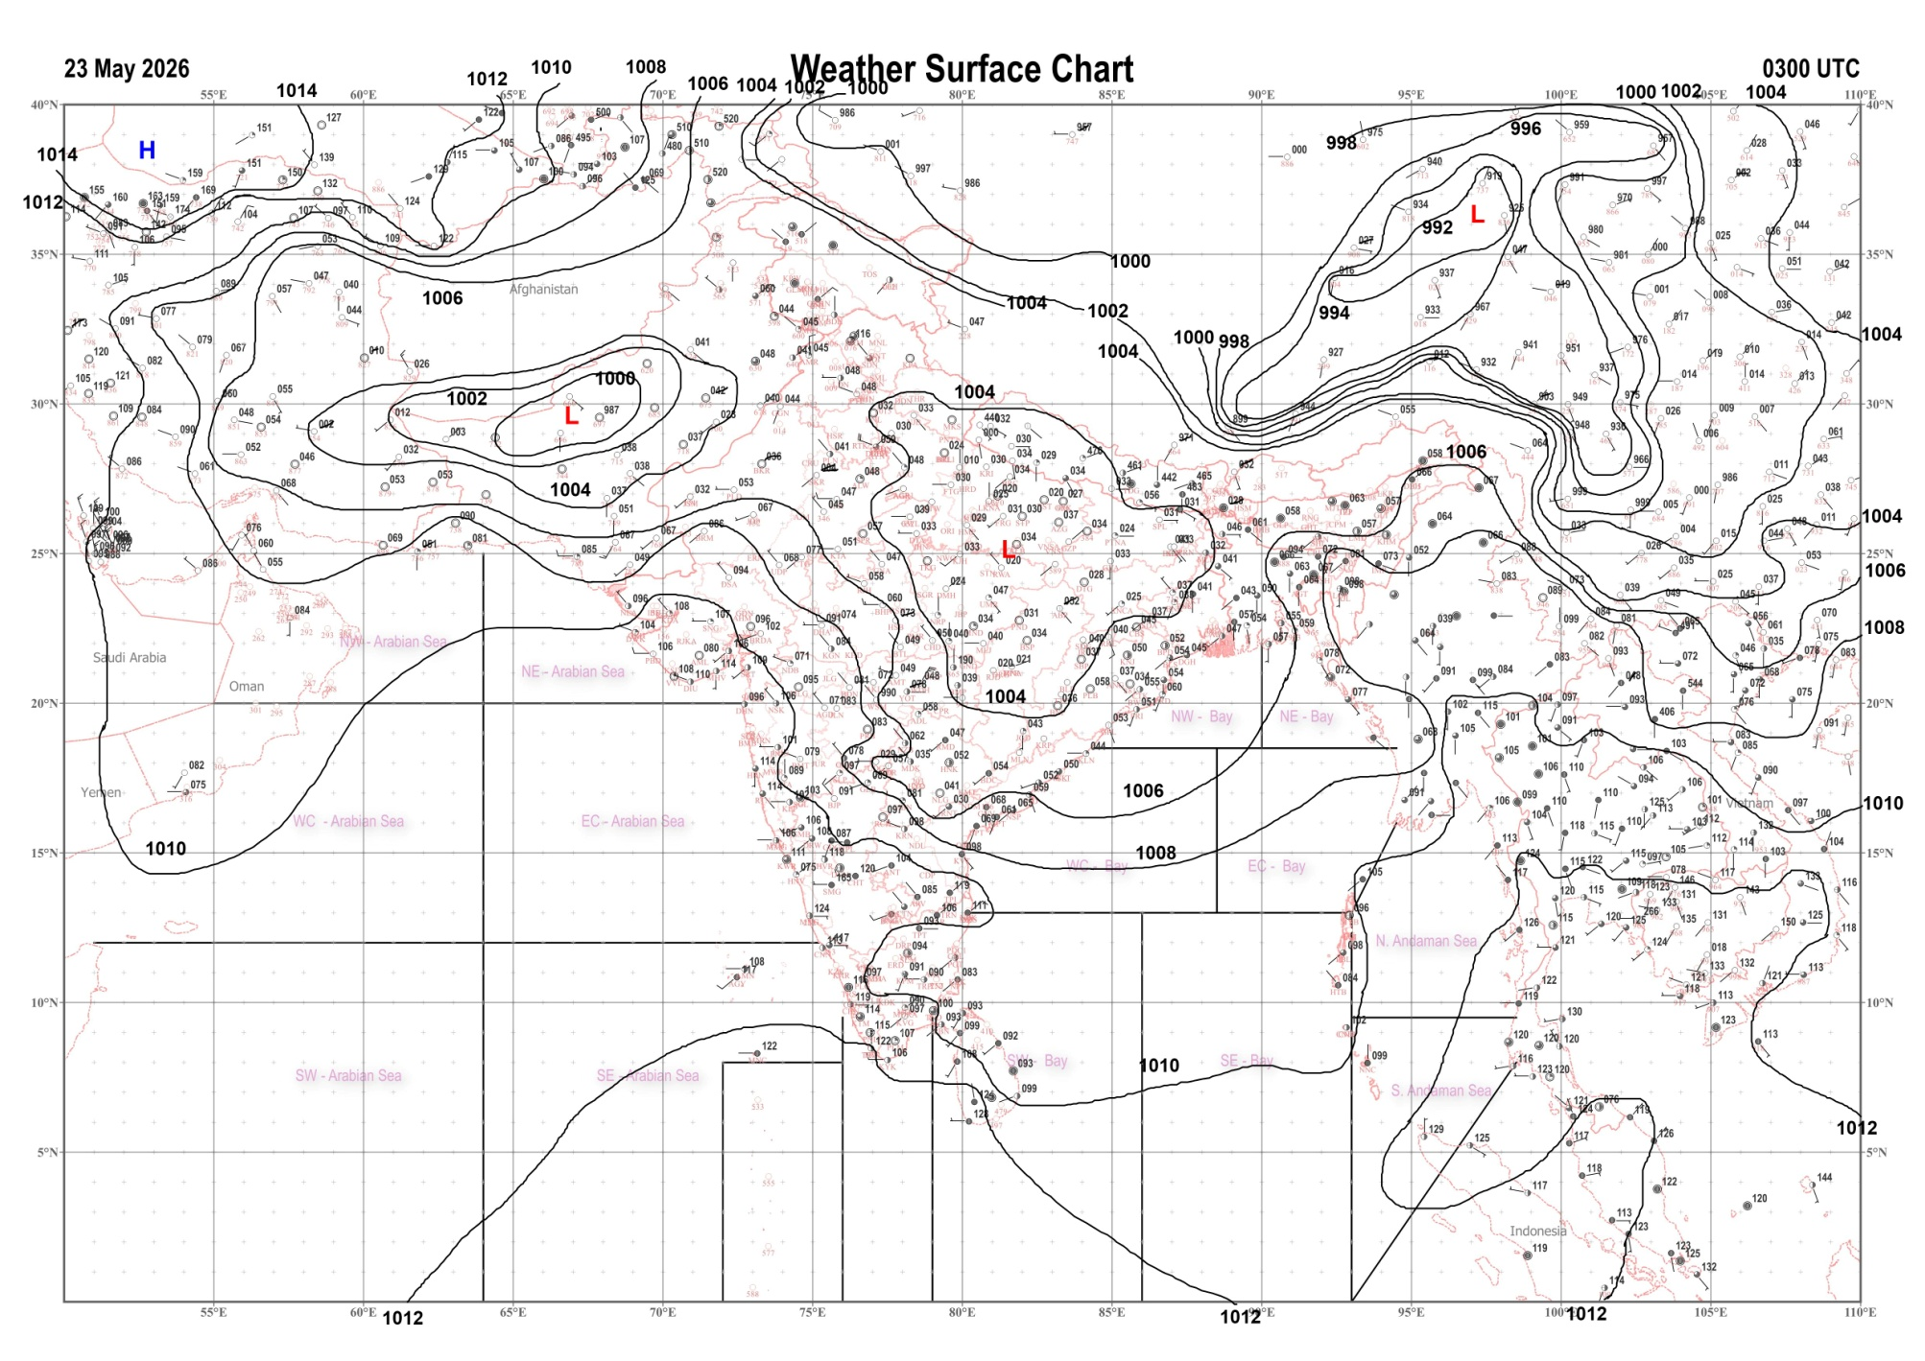 | 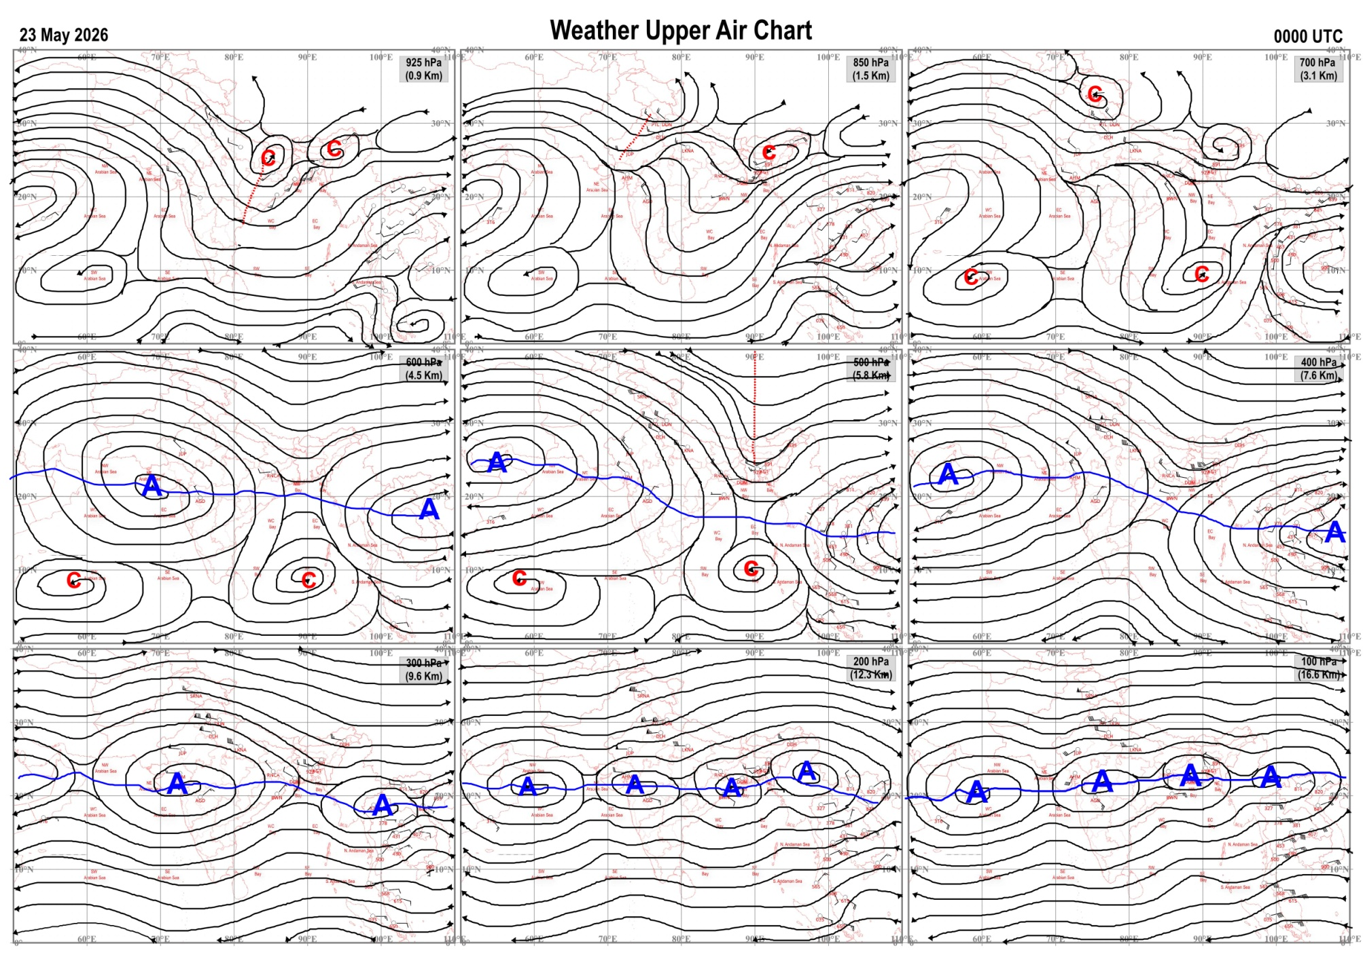
Fig.1. Analysed surface chart based on 03z observation | Fig.2. Analysed upper air chart based on 00z observation
Dr. S.D.Sanap
Scientist ‘D’
CR & S Office, Pune  Issued at 1245 hrs. IST |  | Weather Forecasting Division  CR&S, Pune

Indian regions | Realised rainfall (chief amount in cm during past 24 hrs):
East | most places: Sub-Himalayan West Bengal & Sikkim+++  many places: Arunachal Pradesh+ and Assam & Meghalaya+  a few places: Nagaland-Manipur-Mizoram-Tripura+  isolated places: Gangetic West Bengal, Odisha, Jharkhand and Bihar+  Beech tea garden 17.7, Jaybirpara tea estate 12.8, Matijuri 11.4, Silchar & Hasimara 10.8 each, Oyan ARG 10.5, Cherrapunji (rkm) 10.4, Kamalpur 9.5, Daparijo 8.1, Baisa 6.9, Daporizo AWS 6.5, Chottabekra 6.4, Forbesganj 6.3, Narpatganj 5.0, Kaliasole 4.0, Imphal AP & Gunupur 3.0 each, Asansol & Mahendragarh 1.7 each, Asansol (CWC) , Gopalpur & Amrapara 1.6 each, Luchipur 0.8.
North | a few places: Himachal Pradesh and Jammu-Kashmir and Ladakh  isolated places: Uttarakhand, Haryana◆ and Punjab◆  dry weather: Uttar Pradesh and Rajasthan  Purola 2.0, Nichar 1.7, Sarahan 1.5, Lolab 1.3, Bandipora 1.2, Barkot, Manali & Kupwara 1.0 each, Dharchula 0.6, Pusa AWS, Ballowal saunkri & Faridkot 0.2 each.
Central | dry weather: Madhya Pradesh, Vidarbha and Chhattisgarh
Peninsula | a few places: coastal Andhra Pradesh  isolated places: Konkan & Goa, Madhya Maharashtra, Marathwada, Rayalaseema, Tamil Nadu, coastal Karnataka, north interior Karnataka◆, south interior Karnataka and Kerala  dry weather: Gujarat State and Telangana  Chinchwad ARG 6.1, Ambegaon ghodegaon, Srungavarapukota & Kozhikode 4.2 each, Nalumukku 4.0, Polur 3.7, Gantyada 3.4, Karumadi AWS 2.4, Kayamkulam ARG 2.3, Tirupathur PTO 2.2, Sudhagad pali 1.8, Chikkanahalli AWS 1.7, Vaijapur 1.6, Khalapur 1.5, Rudravaram 1.4, Pune 1.3, Visakhapatnam AP 1.1, Tadpatri 0.8, Rampura 0.6, Shakti Nagar 0.5, Matheran 0.4, Uppinangadi & Gokarna 0.3 each, Gangavathi ARG 0.2, Chitradurga 0.1.
Islands | most places: Andaman & Nicobar  many places: Lakshadweep  Long island 6.0, Maya bandar 3.6, Port blair 1.7, Amini 1.1, Agathi 0.4, Minicoy 0.2.
Table-2 Forecast / warnings (distribution of rain / thundershowers) for 7 days (valid from time of origin upto 0830 hrs IST of next day)
Sr N. |  | Sub-division Name | Day 1 | Day 2 | Day 3 | Day 4 | Day 5 | Day 6 | Day 7 | Sr. No. | Sub-division Name | Day 1 | Day 2 | Day 3 | Day 4 | Day 5 | Day 6 | Day 7
 |  |  | 23 May | 24 May | 25 May | 26 May | 27 May | 28 May | 29 May |  |  | 23 May | 24 May | 25 May | 26 May | 27 May | 28 May | 29 May
 | 1 | Andaman Nicobar Islands | W +  | W+ | W  | W  | W  | W  | W  | 19 | west Madhya Pradesh | I + | I + | D + | D + | D + | D | D +
 | 2 | Arunachal Pradesh | W ++  | W + | W +  | W +  | F + | F | F | 20 | east Madhya Pradesh | D + | D + | D + | D + | D + | D + | I +
 | 3 | Assam-Meghalaya | W ++  | W ++  | W ++  | W +  | F  | F | F | 21 | Gujarat region | I | D | D | D | D | D | D
 | 4 | Nagaland-Manipur-Mizoram-Tripura | W +  | F +  | F  | F  | F  | F | F | 22 | Saurashtra and Kutch | I | D | D | D | D | D | D
 | 5 | Sub Him West Bengal/Sikkim | W ++  | W ++  | W +  | W +  | W | F | F | 23 | Konkan and Goa | I  | I  | I | I | I | I | I
 | 6 | Gangetic West Bengal | I + | I + | I + | I + | I  | S  | S  | 24 | Madhya Maharashtra | I  | I  | I | I | I | I | I
 | 7 | Odisha | I + | I + | I + | I + | I+ | I | I | 25 | Marathwada | I  | I | I | D | D | D | I
 | 8 | Jharkhand | I + | I + | I + | I + | I  | S  | S  | 26 | Vidarbha | D + | D + | D + | D + | D + | D | D +
 | 9 | Bihar | I + | I+ | S +  | S +  | I  | I  | I  | 27 | Chhattisgarh | D + | D + | D + | I + | I+ | I  | I 
 | 10 | east Uttar Pradesh | D + | D + | D + | D + | I + | I | I + | 28 | Coastal Andhra Pradesh and Yanam | I + | S + | S  | S  | S  | S | F
 | 11 | west Uttar Pradesh | I + | I + | D + | D + | D + | I | I + | 29 | Telangana | I + | I + | I+ | I + | I  | I | I
 | 12 | Uttarakhand | I  | I | S  | I + | I | I | S + | 30 | Rayalaseema | S +  | S  | S  | I | I | I | I
 | 13 | Haryana,Chandigarh and Delhi | I  | D + | D + | D + | D + | I  | I+ | 31 | Tamil Nadu, Puducherry and Karaikal | I ++ | S +  | S +  | I +  | I | I | I
 | 14 | Punjab | I  | D + | D + | D + | D + | I  | I+ | 32 | Coastal Karnataka | I  | I  | S  | S  | S  | S | F
 | 15 | Himachal Pradesh | I  | I | I | D + | D + | S | F | 33 | North interior Karnataka | I  | I  | I | I  | I  | S | F
 | 16 | Jammu-Kashmir and Ladakh | S  | S  | S  | D + | D + | S | S + | 34 | South interior Karnataka | S +  | I  | I | I  | S  | S | F
 | 17 | west Rajasthan | I + | D + | D + | D + | D + | D + | D + | 35 | Kerala and Mahe | W +  | W +  | W + | W +  | W+ | W + | W +
 | 18 | east Rajasthan | I + | D + | D + | D + | D + | D | D + | 36 | Lakshadweep | W  | W +  | W+  | W +  | W+ | W | W
Legends: D = Dry I =isolated S = Scattered F = Fairly widespread W = Widespread #= heavy to very heavy rain at a few places with extremely heavy rain at isolated places+++= heavy rain at a few places with very heavy rain at isoIated places++= heavy to very heavy rainfall @=isolated exceptionally heavy rainfall+ = heavy rain ●/*= rain or snow ♦ = very light rain ≡=fog = thunderstorm with lightning =Squall / Gusty / gale / strong wind -=cold wave/cold day + = heat wave/warm night/hot and humid weather =Duststorm =ground frost = Hail.
Fig. 4: Districtwise warnings for five days for Maharashtra State
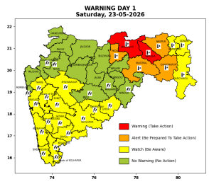 | 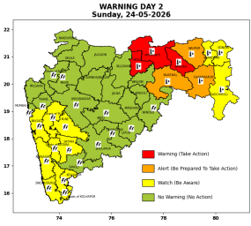 | 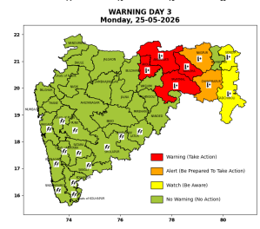 | 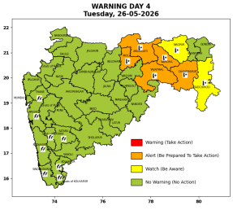 | 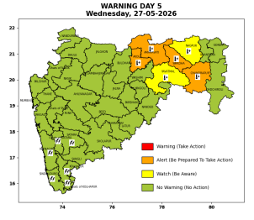

Pune, Lohegaon and Pashan observations at 0830 hrs. IST of Today
 | Temperature (°C) |  |  |  |  | Humidity (%) |  |  |  | Rainfall (mm)
 | Max.  past  24 hrs | Dep.  from  normal | Min.  past  24 hrs. | Dep.  from  normal | Dry  Bulb | At 0830 hrs. IST | Dep.  From  normal | At 1730  hrs. IST of ‘y’day | Dep.  from  normal | Past  24 hrs. | Since  1st March | Dep.  from  normal
PNE | 37.0 | 0.4 | 22.7 | -1.0 | 27.6 | 78 | 15 | 95 | 55 | 13.3 | 106.1 | 71.1
PSN | 37.6 | - | - | - | - | - | - | 100 | - | - | - | -
LHG | 39.2 | 3.2 | 24.6 | 3.6 | 28.2 | 74 | 11 | 81 | 42 | 16.2 | 107.6 | 65.4

 |  |  |  |  |  |  | Local (Pune and neighbourhood) forecast
Max./Min. Temperature (°C) |  |  |  |  |  |  |  |  | Weather
Date | Pune | Pashan | Lohegaon | Chinchwad | Lavale | Magarpatta | NDA | Koregoan park
23/05/26 | 37 / 22.7* | 37 / - | 36 / 24.6* | 36 / 22.0* | 36 / 21.5* | 39 / 23.9* | 34 / 22.9* | 38 / 24.4* | Mainly clear sky becoming partly cloudy sky towards afternoon or evening. Thunderstorm with lightning, light rain very likely.
24/05/26 | 38 / 24 | 38 / 24 | 38 / 26 | 37 / 23 | 37 / 22 | 39 / 25 | 35 / 24 | 39 / 25 | Mainly clear sky becoming partly cloudy sky towards afternoon or evening.
25/05/26 | 38 / 24 | 38 / 24 | 38 / 26 | 37 / 23 | 37 / 22 | 39 / 25 | 35 / 24 | 39 / 25 | Mainly clear sky becoming partly cloudy sky towards afternoon or evening.
26/05/26 | 39 / 25 | 39 / 25 | 39 / 27 | 38 / 24 | 38 / 23 | 40 / 26 | 36 / 25 | 40 / 26 | Mainly clear sky becoming partly cloudy sky towards afternoon or evening.
27/05/26 | 39 / 25 | 39 / 25 | 39 / 27 | 38 / 24 | 38 / 23 | 40 / 26 | 36 / 25 | 40 / 26 | Mainly clear sky becoming partly cloudy sky towards afternoon or evening.
28/05/26 | 38 / 24 | 38 / 24 | 38 / 26 | 37 / 23 | 37 / 22 | 39 / 25 | 35 / 24 | 39 / 25 | Mainly clear sky becoming partly cloudy sky towards afternoon or evening.
29/05/26 | 38 / 23 | 38 / 23 | 38 / 25 | 37 / 22 | 37 / 21 | 39 / 24 | 35 / 23 | 39 / 24 | Mainly clear sky becoming partly cloudy sky towards afternoon or evening.
Rainfall Distribution |  |  |  |  | Rainfall Categories | Rainfall (mm) | Cloud condition |  | Rainfall Intensity | Range
Widespread (W) | 76-100% |  |  |  | Very Light rain | Trace to 2.4 mm | Mainly clear sky | 1-2 oktas | Light Spell | 1 cm/hr
 |  |  |  |  | Light rain | 2.5 to 15.5 mm | Partly cloudy sky | 3-4 oktas | Moderate Spell | 1-2 cm/hr
Fairly Widespread (FW) | 51 – 75% |  |  |  | Moderate rain | 15.6 to 64.4 mm | Generally cloudy sky | 5-7 oktas | Intense Spell | 2-3 cm/hr
Scattered (S) | 26 – 50% |  |  |  | Heavy rain | 64.5 to 115.5 mm | Overcast | 8 oktas | Very Intense Spell | 3-5 cm/hr
Isolated (I) | 1 – 25% |  |  |  | Very heavy rain | 115.6 to 204.4 mm |  |  | Extremely Intense Spell | 5-10 cm/hr
Dry (D) | No Rain |  |  |  | Extremely heavy rain | ≥ 204.5 mm |  |  | Cloudburst | > 10 cm/hr
Probability Terms in %: |  |  |  |  | Heavy snow | 6.5 to 11.5 cms water equivalent of rain
unlikely | < 25 |  |  |  | Very heavy snow | 11.6 to 20.4 cms water equivalent of rain
likely | between 25 50
very likely | between 51 75
most likely | >75
* = realized temperature
Mumbai (Colaba) |  |  |  | Nagpur (AP)
Date 2026 | T max °C | T min °C | Weather | T max °C | T min °C | Weather
23/05/26 | 33 | 27 | Generally cloudy sky with Light Rain or Drizzle. | 46 | 29 | Heat Wave.
24/05/26 | 33 | 27 | Generally cloudy sky with Light Rain or Drizzle. | 46 | 29 | Heat Wave.
25/05/26 | 34 | 27 | Partly cloudy sky. | 45 | 29 | Heat Wave.
26/05/26 | 35 | 27 | Clear sky. | 45 | 29 | Heat Wave.
27/05/26 | 35 | 27 | Clear sky. | 46 | 28 | Heat Wave.
28/05/26 | 34 | 27 | Clear sky. | 45 | 28 | Heat Wave.
29/05/26 | 34 | 27 | Clear sky. | 45 | 30 | Heat Wave.

